**SQL Query Code and Result**

## SQL Code:

SELECT * FROM bank_loan_data

/* ------------ Dashboard 1: Summary------------ */  
/* -----KPI's------ */  
**1. Total Loan Applications**  
SELECT COUNT(id) Total_Applications  
FROM bank_loan_data

  
  
--MTD Loan Applications  
SELECT COUNT(id) MTD_Total_Applications  
FROM bank_loan_data  
WHERE MONTH(issue_date) = 12

  
  
--PMTD Loan Applications  
SELECT COUNT(id) AS PMTD_Total_Applications FROM bank_loan_data  
WHERE MONTH(issue_date) = 11

  
----------------------------------------------------------------------------------------------------------------------

**2.Total Funded Amount**  
SELECT SUM(loan_amount) Total_Funded_Amount  
FROM bank_loan_data



--MTD Loan Applications  
SELECT SUM(loan_amount) MTD_Total_Funded_Amount  
FROM bank_loan_data  
WHERE MONTH(issue_date) = 12 AND YEAR(issue_date) = 2021



--PMTD Total Funded Amount  
SELECT SUM(loan_amount) AS PMTD_Total_Funded_Amount FROM bank_loan_data  
WHERE MONTH(issue_date) = 11



----------------------------------------------------------------------------------------------------------------------  
  
**3.Total Amount Received**SELECT SUM(total_payment) Total_Amount_Received  
FROM bank_loan_data



--MTD Total Amount Received  
SELECT SUM(total_payment) AS MTD_Total_Amount_Received FROM bank_loan_data  
WHERE MONTH(issue_date) = 12



--PMTD Total Amount Received  
SELECT SUM(total_payment) AS PMTD_Total_Amount_Received FROM bank_loan_data  
WHERE MONTH(issue_date) = 11

  
----------------------------------------------------------------------------------------------------------------------  
  
**4. Average Interest Rate**  
SELECT ROUND(AVG(int_rate),4)*100 As Average_Interest_Rate  
FROM bank_loan_data



--MTD Average Interest  
SELECT AVG(int_rate)*100 AS MTD_Avg_Int_Rate FROM bank_loan_data  
WHERE MONTH(issue_date) = 12



--PMTD Average Interest  
SELECT AVG(int_rate)*100 AS PMTD_Avg_Int_Rate FROM bank_loan_data  
WHERE MONTH(issue_date) = 11



**5.Average Debt-to-Income Ratio (DTI)**  
SELECT ROUND(AVG(dti),4)*100 Average_DTI  
FROM bank_loan_data



--MTD Avg DTI  
SELECT AVG(dti)*100 AS MTD_Avg_DTI FROM bank_loan_data  
WHERE MONTH(issue_date) = 12



--PMTD Avg DTI  
SELECT AVG(dti)*100 AS PMTD_Avg_DTI FROM bank_loan_data  
WHERE MONTH(issue_date) = 11



----------------------------------------------------------------------------------------------------------------------  
  
/* ------------Good Loan Issued-----------*/  
**1. Good Loan Percentage**  
SELECT   
 (COUNT(CASE WHEN loan_status = 'Fully paid' OR loan_status = 'Current'  
 THEN id END)*100)  
 / COUNT(id) Good_Loan_Percentage  
FROM bank_loan_data

  
  
**2. Good Loan Applications**  
SELECT COUNT(id) Good_Loan_Applications  
FROM bank_loan_data  
WHERE loan_status = 'Fully paid' OR loan_status = 'Current'

  
  
**3.Good Loan Funded Amount**  
SELECT SUM(loan_amount) Good_Loan_Funded_Amount  
FROM bank_loan_data  
WHERE loan_status = 'Fully paid' OR loan_status = 'Current'

  
  
**4.Good Loan Amount Received**  
SELECT SUM(total_payment) Good_Loan_Amount_Received  
FROM bank_loan_data  
WHERE loan_status = 'Fully paid' OR loan_status = 'Current'



----------------------------------------------------------------------------------------------------------------------  
  
/* ------------Bad Loan Issued-----------*/  
**1. Bad Loan Percentage**  
SELECT   
 (COUNT(CASE WHEN loan_status = 'Charged Off' THEN id END)*100)  
 / COUNT(id) Bad_Loan_Percentage  
FROM bank_loan_data

  
  
**2. Bad Loan Applications**  
SELECT COUNT(id) Bad_Loan_Applications  
FROM bank_loan_data  
WHERE loan_status = 'Charged Off'

  
  
**3.Bad Loan Funded Amount**SELECT SUM(loan_amount) Bad_Loan_Funded_Amount  
FROM bank_loan_data  
WHERE loan_status = 'Charged Off'

  
  
**4.Bad Loan Amount Received**SELECT SUM(total_payment) Bad_Loan_Amount_Received  
FROM bank_loan_data  
WHERE loan_status = 'Charged Off'



----------------------------------------------------------------------------------------------------------------------

/* ----------Loan Status-------------- */  
SELECT   
 loan_status,  
 COUNT(id)Loan_Count,  
 SUM(total_payment) Total_Amount_Received,   
 SUM(loan_amount) Total_Funded_Amount,  
 AVG(int_rate)*100 Avg_Interest_Rate,  
 AVG(dti)*100 Avg_DTI  
FROM bank_loan_data  
GROUP BY loan_status

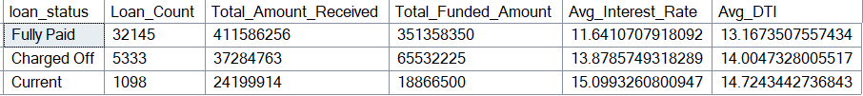  
  
SELECT   
 loan_status,  
 SUM(total_payment) MTD_Total_Amount,  
 SUM(loan_amount) MTD_Total_Funded_Amount  
FROM bank_loan_data  
WHERE MONTH(issue_date) = 12  
GROUP BY loan_status

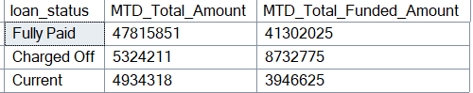

----------------------------------------------------------------------------------------------------------------------  
  
/* ------------ Dashboard 2: Overview ------------ */  
**1.Monthly Trends by Issue Date**SELECT   
 MONTH(issue_date) Month,  
 DATENAME(MONTH, issue_date) Month_Name,  
 COUNT(id) Total_Loan_Applications,  
 SUM(loan_amount) Total_Funded_Amount,  
 SUM(total_payment) Total_Received_Amount  
FROM bank_loan_data  
GROUP BY MONTH(issue_date), DATENAME(MONTH, issue_date)  
ORDER BY MONTH(issue_date)

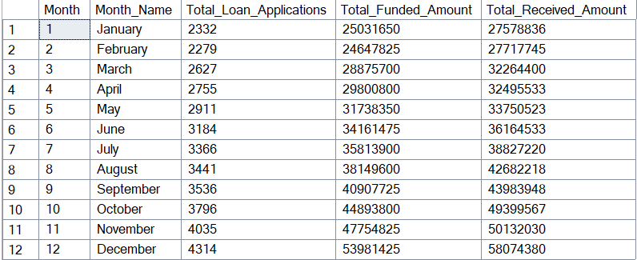

**2.Regional Analysis by State**SELECT   
 address_state,  
 COUNT(id) Total_Loan_Applications,  
 SUM(loan_amount) Total_Funded_Amount,  
 SUM(total_payment) Total_Received_Amount  
FROM bank_loan_data  
GROUP BY address_state  
ORDER BY address_state

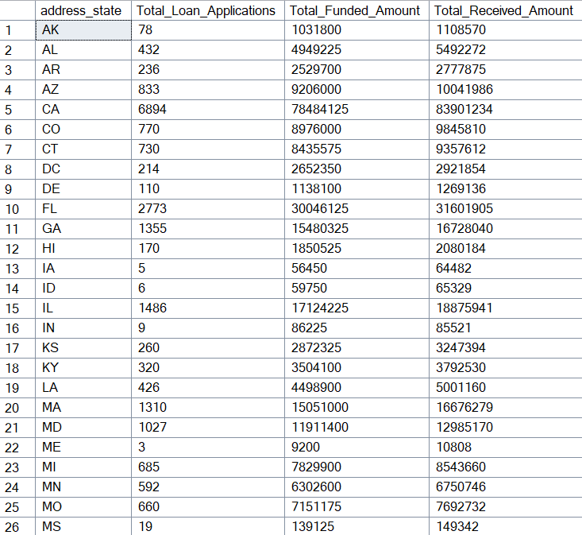

**3.Loan Term Analysis**  
SELECT   
 term,  
 COUNT(id) Total_Loan_Applications,  
 SUM(loan_amount) Total_Funded_Amount,  
 SUM(total_payment) Total_Received_Amount  
FROM bank_loan_data  
GROUP BY term  
ORDER BY term

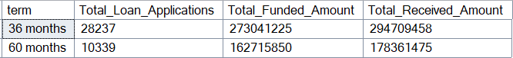  
  
**4.Employee Length Analysis**  
SELECT   
 emp_length,  
 COUNT(id) Total_Loan_Applications,  
 SUM(loan_amount) Total_Funded_Amount,  
 SUM(total_payment) Total_Received_Amount  
FROM bank_loan_data  
GROUP BY emp_length  
ORDER BY emp_length

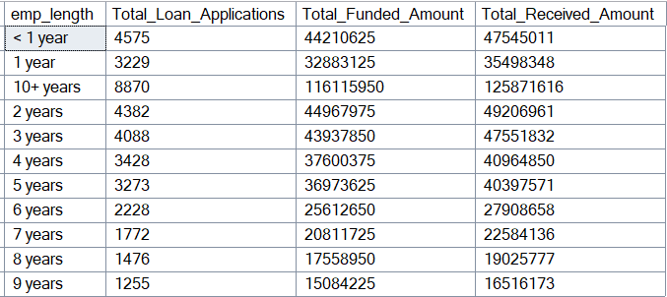  
  
**5.Loan Purpose Breakdown**   
SELECT   
 purpose,  
 COUNT(id) Total_Loan_Applications,  
 SUM(loan_amount) Total_Funded_Amount,  
 SUM(total_payment) Total_Received_Amount  
FROM bank_loan_data  
GROUP BY purpose  
ORDER BY purpose

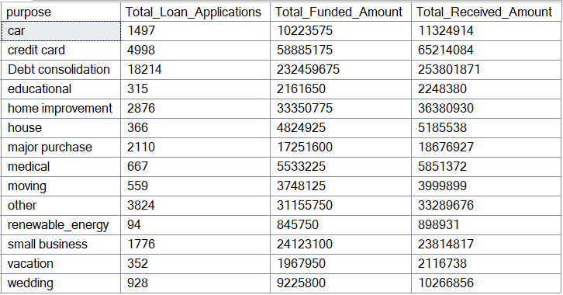  
  
--6.Home Ownership Analysis   
SELECT   
 home_ownership,  
 COUNT(id) Total_Loan_Applications,  
 SUM(loan_amount) Total_Funded_Amount,  
 SUM(total_payment) Total_Received_Amount  
FROM bank_loan_data  
GROUP BY home_ownership  
ORDER BY home_ownership

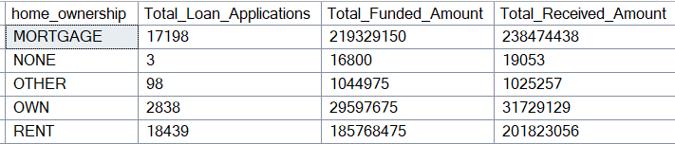

*Note: We have applied multiple Filters on all the dashboards. You can check the results for the filters as well by modifying the query and comparing the results.*

*For e.g*

*See the results when we hit the Grade A in the filters for dashboards.*

SELECT   
 purpose AS PURPOSE,

COUNT(id) Total_Loan_Applications,

SUM(loan_amount) Total_Funded_Amount,  
 SUM(total_payment) Total_Received_Amount

FROM bank_loan_data

WHERE grade = 'A'

GROUP BY purpose

ORDER BY purpose

